Hybrid Navigation and Global Positioning System
Learning Objectives
- Introduction to Navigation systems
- What is a global positioning system (GPS)?
- Advantages and disadvantages of the GPS
- Applications of the GPS
- Robotics and the GPS
- What is hybrid navigation?
- Navigation techniques used in hybrid navigation systems such as sensor fusion, interior navigation system (INS), differential GPS (DGPS) and wi-fi positioning system (WPS)
- Applications of hybrid navigation systems

Navigation
Navigation is the science of accurately ascertaining an object or entity’s position, planning and following a route to a specified destination. Many use navigation methods to cruise an area. The earliest and most common navigation method involves observing landmarks or known locations. In the open sea, where there are no visible landmarks, ancient sailors used the constellations and the direction of the sun and stars to mark their position. Mariners also used an astrolabe, an instrument developed by astronomers to measure the height of celestial bodies above the horizon; this tool assisted in determining a ship's latitude from the height of the pole star or the sun. Another tool used is the compass, used for land, sea and air navigation by using the Earth’s magnetic poles.
The development of sensors, computers, data transmission techniques and systems theory accelerated the advancement of navigation systems. The accelerated trend navigation system was motivated and sponsored by military marine and air operations, helicopter development, space operations.
Global positioning system (GPS)
The global positioning system, also known as GPS, was conceived in 1960, under the auspices of the U.S Military. Currently, the GPS consists of 32 satellites that circle the globe every 12 hours at 12,000 miles in altitude, allowing precise identification of any location in the Earth by measuring the distance between the satellites. The satellites are arranged in their orbits so a GPS receiver on Earth can receive their signals at any given time. These transmit low radio signals with unique codes in different frequencies. The main purpose of these coded signals is to allow for calculating the travel time from the satellite to the GPS receiver, which provides accurate location in latitude, longitude, altitude, and time.
Additional information: GPS: Everything you need to know about the space-based technology keeping us on track

Advantages and disadvantages
Advantages
Real-time location tracking - The GPS technology has the ability to track, in real time, the position of any vehicle, structure, object or entity. This enables route optimization that improves overall efficiency.
Emergency assistance and tracking - In emergencies, this technology can be used to quickly locate individuals and assets and dispatch emergency services. Similarly, GPS can be utilized to monitor the safety of individuals working in remote or dangerous locations.
Automation and increased ability of performing tasks remotely - GPS technology allows individuals and businesses to automate tasks such as tracking and route planning, reducing manual labor. As well as enabling the performance of remote tasks like monitoring equipment and collecting data.
Safety and security - GPS can save lives by preventing transportation accidents, aiding search and rescue efforts and disaster relief. Additionally, it helps scientific aims such as weather forecasting, earthquake monitoring and environmental protection. Furthermore, it's a critical tool for national security where it is integrated into every faucet of U.S military operations.

Disadvantages
Limited functionality in certain areas - As GPS depends on the satellites that orbit the Earth, dense areas like urban canyons, dense forests, underwater and remote locations with no sight to the sky, the signals from satellites can be blocked and limit its functionality.
Potential signal interference - The signals from the satellites can be disrupted by solar flares, atmospheric conditions, interferences that can cause errors in location data or temporary loss of service.
Risk to privacy and civil liberties - GPS technology can be used for tracking and surveillance, which poses a risk to safety. On the other hand, this technology can be leveraged by hackers and can be used to collect and store personal data.
Lack of backup plan in case of system outage - if the system were to fail, there is lack of a back up plan to fall back on, and the cost could be immeasurable. Some examples of the ramifications that can result from a GPS failure are radio equipment for police and fire departments can malfunction, anomalies in power grids and boats would be stranded at sea.

Applications
The GPS is used in many sectors including:
Agriculture - GPS based applications in precision farming are being used for farm planning, field mapping, tractor guidance, etc. On the other hand, this technology allows farmers to work during low visibility field conditions such as rain, dust, fog and darkness. Precision agriculture consists of collecting timely geospatial information on soil, plants and animal requirements and prescribing solutions for agricultural production. GPS tracking can be found in harvesters, mowers, trailers, sprayers, scrapers and ensure optimal use of farming assets. Similarly, management can receive real-time information about their equipment location and usage.

Aviation - Most aviation uses the GPS to increase safety and efficiency of the flight. This system allows for navigation in routes of high demand, between perfectly defined points, independent of ground infrastructure. Improved and efficient air routes are made possible because of the GPS. In many cases, these aircraft have to fly over data-scare areas like the ocean, saving time and fuel.
Environment - GPS technology helps evaluate an area’s wildlife, terrain and infrastructure, making conservation efforts possible. This mapping information allows nations to manage their regulatory programs such as the control of royalties from mining operations, delineation of borders and management of logging in forests. In addition, GPS allows monitorization of the changes in the environment. Some examples of usages are GPS receivers mounted on buoys track the spread of oil spills, helicopters use GPS to mark the perimeter of a forest fire, GPS allows the detection of migratory patterns in endangered species to help preserve declining populations.
Marine - The Global Positioning System (GPS) has revolutionized marine operations, particularly in search and rescue efforts. It provides accurate navigation, speed measurement, and location determination for mariners, ensuring safety and efficiency. GPS is crucial for vessels at sea, congested harbors, and waterways, helping them reach their destinations safely and economically.
Public transportation - GPS plays a crucial role in tracking the movement of vehicles in public transportation systems, including buses, trams, and subways, in real time. By combining GPS with other sensors, computers, and communication systems, public transportation operators can enhance safety, security, and operational efficiency. GPS technology helps reduce accidents, delays, and operating costs, while improving passenger satisfaction and optimizing route planning.
Space - GPS revolutionized the way nations operate in space from guidance systems, tracking, control of communication of the satellites, monitoring Earth and space.
Surveying and mapping - The sector was the most benefited and first to take advantage of this technology as it increased productivity, resulting in more accurate and reliable data. Moreover, this GPS-based data collection is much faster than conventional surveying and mapping techniques, reducing manual labor. This technology supports modeling of the physical world, which can be displayed on maps and in geographic information systems (GIS).
More information: GPS applications

Robotics and the GPS
Some robots like autonomous mobile robots for example, use the GPS to position and navigate themselves through long distances. This is done by using both the robot’s and target’s GPS data, which guides the direction of motion of the robot. An erroneous assumption about robots is that the sole use of GPS technology is enough for it to navigate anywhere. However, that is not the case, as there are instances where the GPS will fail. To exemplify, suppose the robot has a GPS receiver and the robot is navigating an urban environment, the tall buildings will decrease the visibility to the sky, making it difficult to obtain the robot’s position. Furthermore, the GPS radio waves are not absorbed in underwater environments, mines, heavy tree canopies or in areas surrounded by metals. Nonetheless, another problem arises; suppose the robot needs to pick up an object, in order to do so the robot can be equipped with a receiver and the object can be equipped with both the receiver and a radio transmitter. Now the robot has the coordinates of the object and can plan a path to get to it, but if this task needs to be done repetitively, every object that the robot needs to pick up would need to be fitted with this instrumentation, thus making it very inefficient. For that reason robots need to be equipped with various perception methods and navigation systems in order to complete tasks with accuracy and efficiency in case the GPS system fails.
Despite the limitations of GPS, it is still widely used in robotics for various reasons:
Global coverage - robots operating in various locations worldwide benefit from the global coverage that the GPS provides. In open sky environments, positioning data is accessible and consistent.
Cost effectiveness - GPS receivers are relatively inexpensive and available. Integrating GPS into robots is a cost effective way of obtaining position information that can later be refined with sensors and other localization tools and mapping techniques.
Redundancy and fault tolerance - Engineers are aware of the limitations of the GPS, for that reason they design robotic systems with redundancy and back up mechanisms by combining other sensors like LiDARS, cameras, inertial measurement units (IMU). By doing so, the robots’ perception and navigation capabilities are enhanced and available to use even in challenging environments.
Aware of the reasons why GPS is still widely used in robots, here are some popular and common examples:
Autonomous cars - self- driving cars rely heavily on GPS technology to determine the location of the vehicle and plan routes. In conjunction with other perception strategies, autonomous cars are able to provide an efficient and safe trip to the passengers.
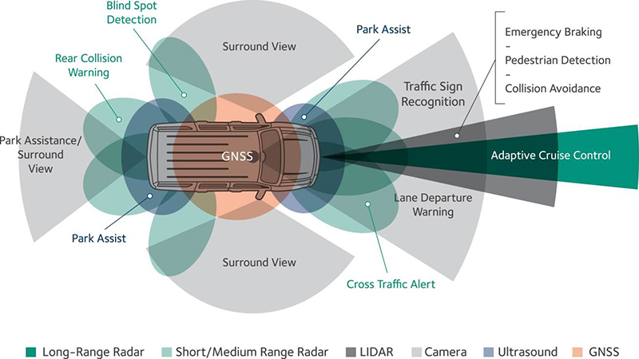

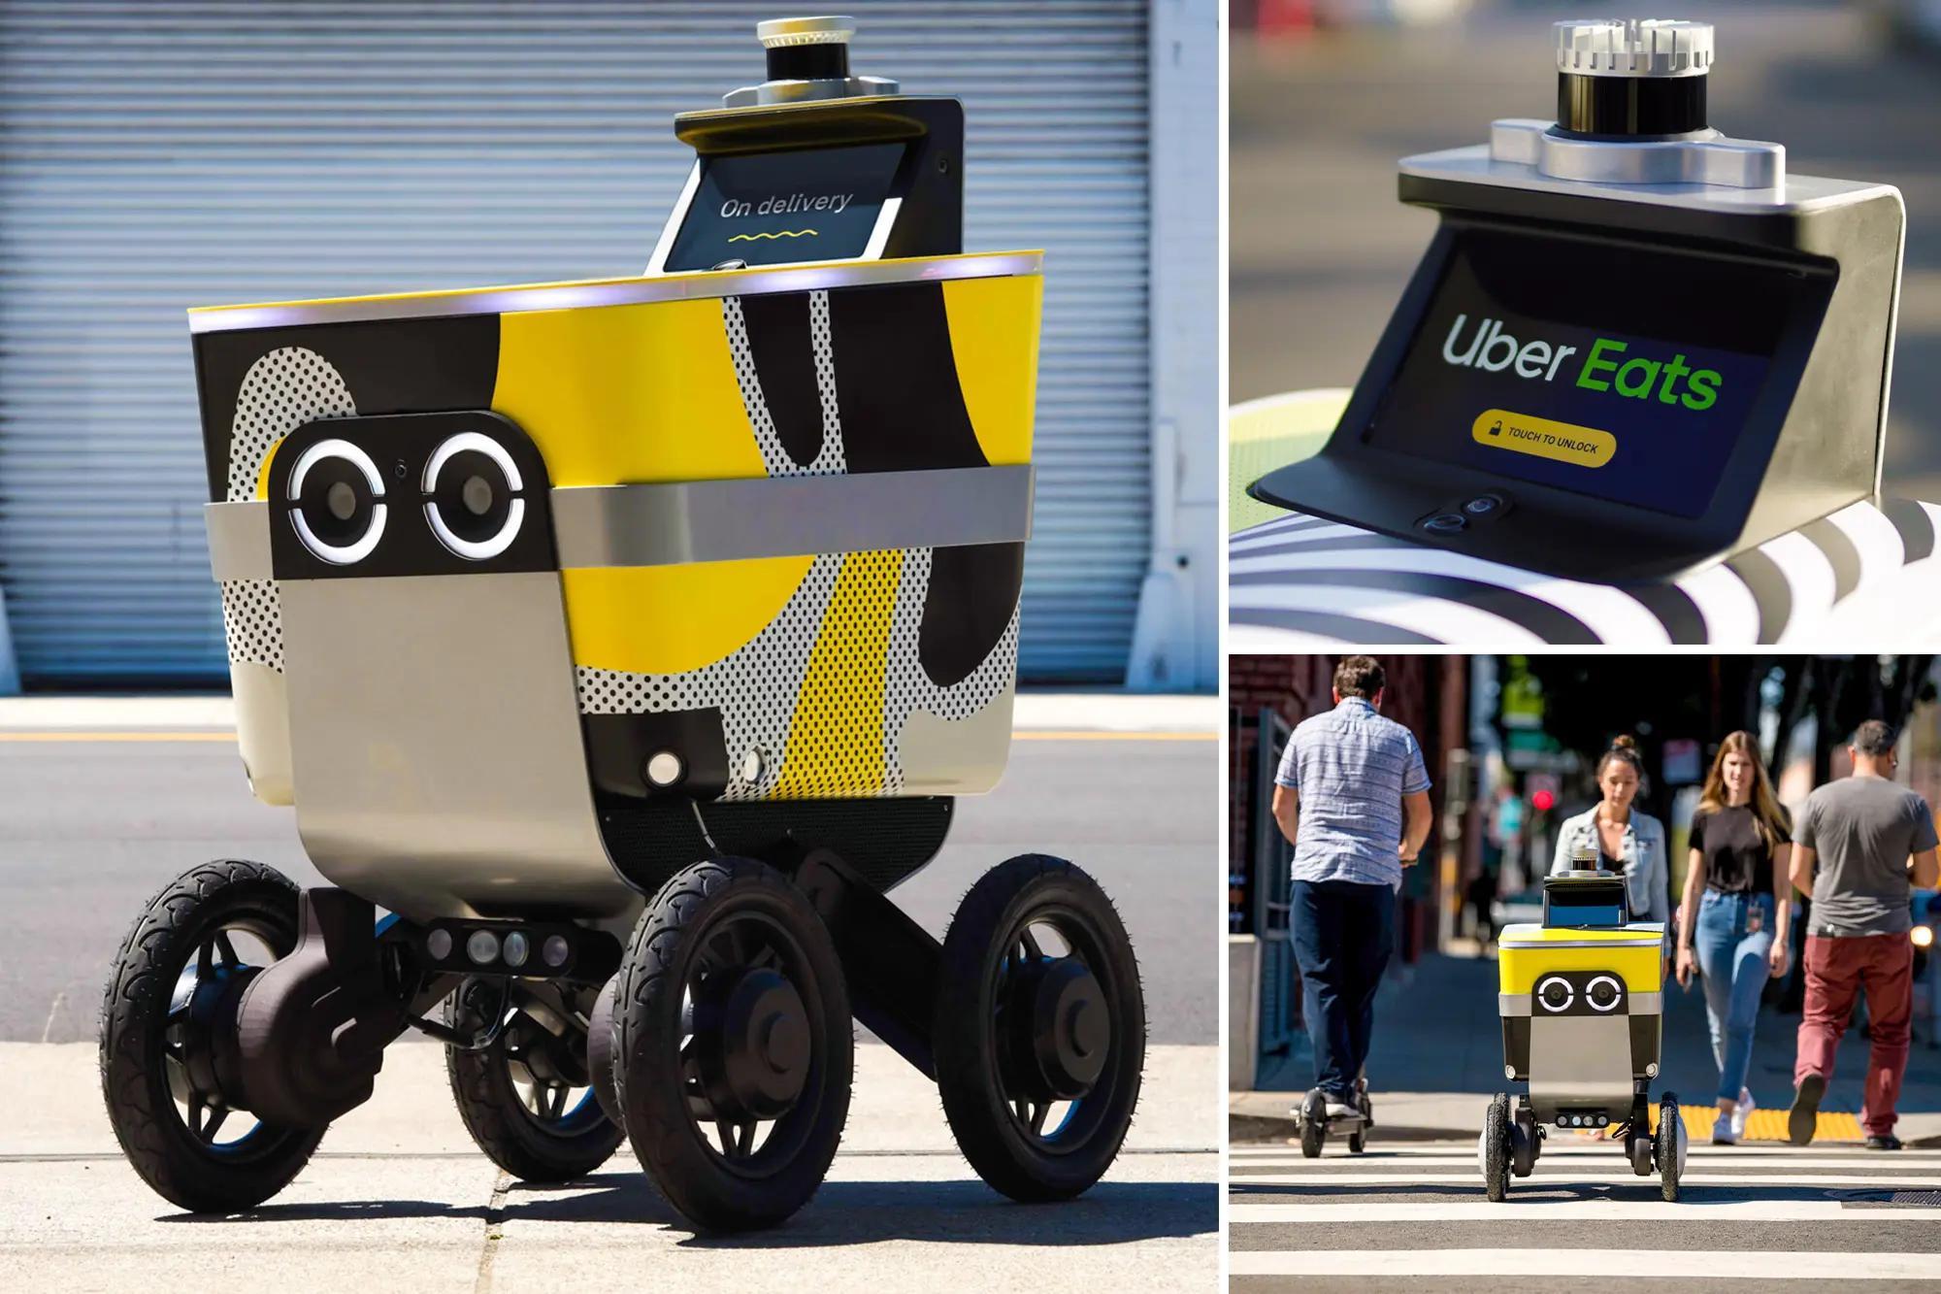
Delivery robots - Although these robots are less common, they are starting to gain popularity in industrial and commercial settings. These robots utilized GPS technology to navigate cities and deliver packages. By using GPS, they map routes and determine the most efficient path to deliver the package to the user. Most of these delivery robots are autonomous wheeled vehicles. Currently, Uber eats in partnership with Serve Robotics to deploy up to 2,000 wheeled robots for take out deliveries.

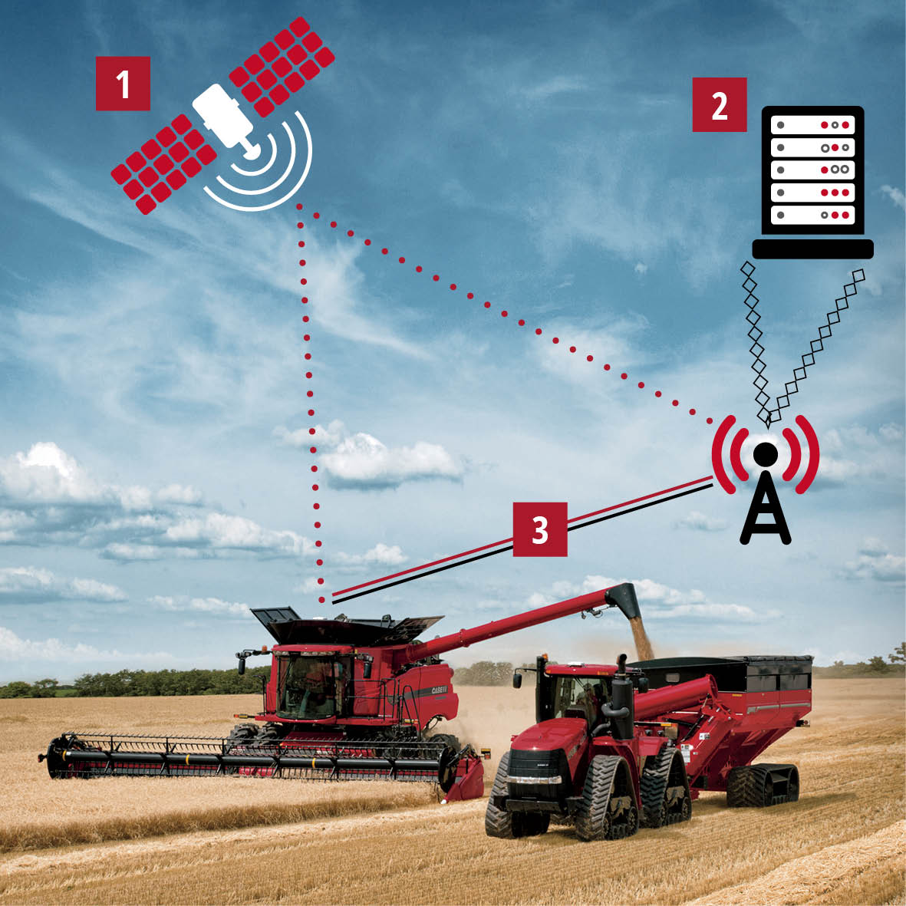
Agricultural robots - GPS is used for agricultural robots for precision farming applications. These robots are equipped with GPS receivers and can navigate the fields to perform tasks like planting seeds, applying fertilizers, spraying pesticides with high accuracy, as agriculture is commonly in open skies.

Search and rescue robots - These autonomous mobile robots benefit by the GPS because it can facilitate navigation through challenging terrains. These types of robots are equipped with sensors and thermal imaging. For example, both autonomous aerial vehicles and autonomous ground vehicles can use thermal imaging to search for survivors after a natural disaster. These robots can help scout an environment that can be dangerous for humans. An example of this was the lunar rover STR-1 that helped clear debris in the Chernobyl Accident zone.
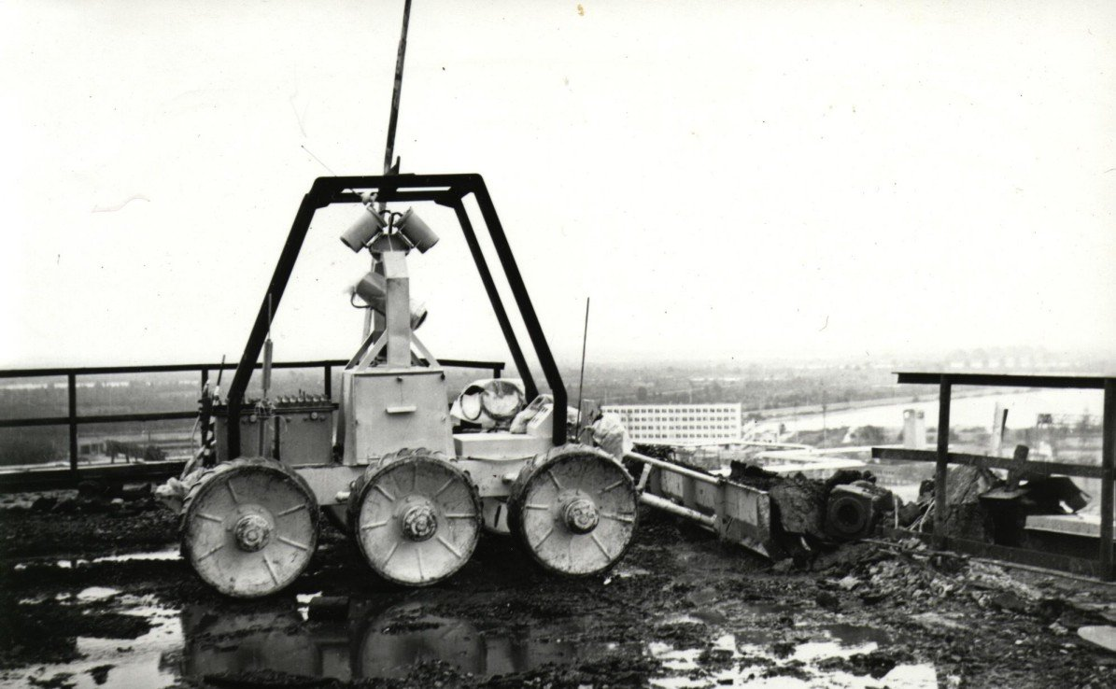

Human-robot interaction - Social robots equipped with GPS functionalities can provide location-based information. For example, a tour guide autonomous mobile robot can locate people and attractions. The robot can then plan a path and guide the user or tourist towards the attraction.

Hybrid navigation
Hybrid navigation systems provide flexibility and stability. These systems are composed of various subsystems that help attain output quantities that are not available from individual components or other systems. The goal is to improve data determination and accuracy by using multiple systems at once.
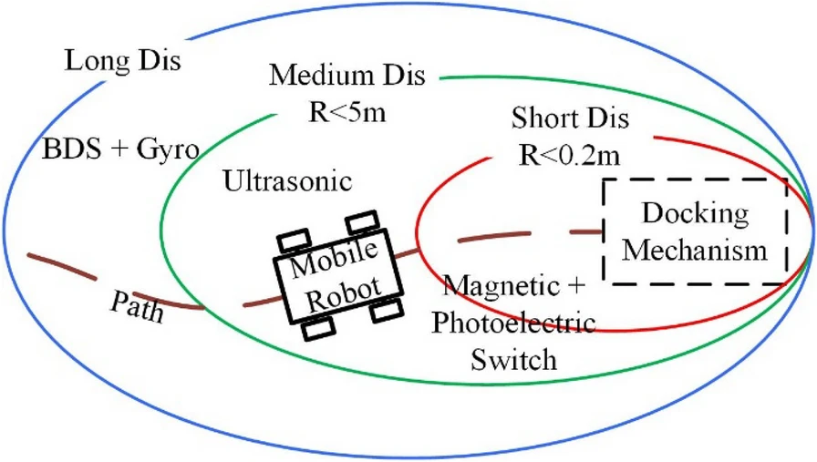

Image from Springer: A schematic of a hybrid navigation system
A hybrid navigation system enables reliable navigation, as if one system fails, the other system can still operate and complete its task. The global positioning system (GPS) is an excellent tool but it has its limitations, and combining this technology with other methods can help get around those drawbacks.
There exists various methods and systems that can be incorporated into a hybrid navigation system:
Sensor fusion - also known as multi-sensor data fusion; refers to the combination of individual sensors to build a unified view of the environment by fusing the data. This allows for more reliable information with less uncertainty.
For more information refer to the Sensor Fusion module of the course.
Inertial navigation system - this dead reckoning navigation technique is used to track the position and orientation of an object relative to a known starting point using accelerometers and gyroscopes. The gyroscopes provide angular rate information, while the accelerometers provide velocity rate information. INS is useful when generating position estimates over long periods of time, independent of landmark visibility.
Differential GPS - DGPS works by measuring errors in the GPS signals. This is done by having a reference system at a known location that measures the errors and corrects them. These corrections are then sent to users in a local area and updated frequently. Common users of differential GPS systems are generally mobile platforms.
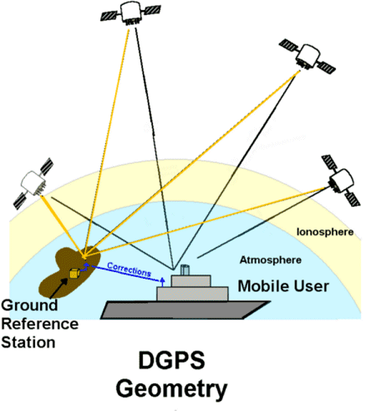

Wi-fi positioning system - WPS is a geolocation system that relies on Wi-Fi to locate users using the device's signal strength. This system can be used in complex indoor environments with obstacles where the GPS signals are weak. Some advantages to Wi-fi positioning system are low access conditions due to the widespread distribution of existing Wi-Fi infrastructure and signals are not affected by line of sight

Applications of hybrid navigation systems
Today, most systems incorporate multiple tools and methods to aid navigation. We can find hybrid navigation systems in:
Aerial vehicles - Aerial vehicles depend on multiple sources of data for smooth navigation. To exemplify, planes depend on GPS data, radio aids and information from radars and ground stations. Another combination of methods is the GPS, INS and Visual Odometry for unmanned aerial vehicles to continuously determine the position of the vehicle.

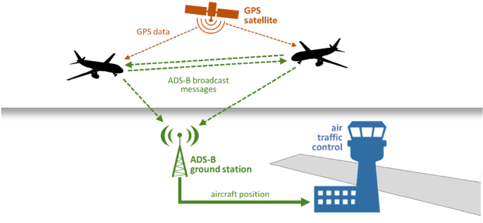

Marine and underwater vehicles - the marine environment lacks visual reference points used in piloted navigation. These vehicles incorporate complex navigation systems to make their way through the vast ocean. Most marine vehicles use the GPS, as the ocean doesn't have structures that obstruct the visibility of the sky, however can also include radars, an inertial navigation system, compasses and Sound Navigation and Ranging (SONAR). As for underwater navigation, GPS is rendered useless as the signals from the satellites don't penetrate underwater. Vehicles like the submarine or autonomous underwater vehicles (AUVs) are forced to use acoustic navigation tools to make their way in deep sea waters like the SONAR. Additionally, they use INS, radars and compasses.

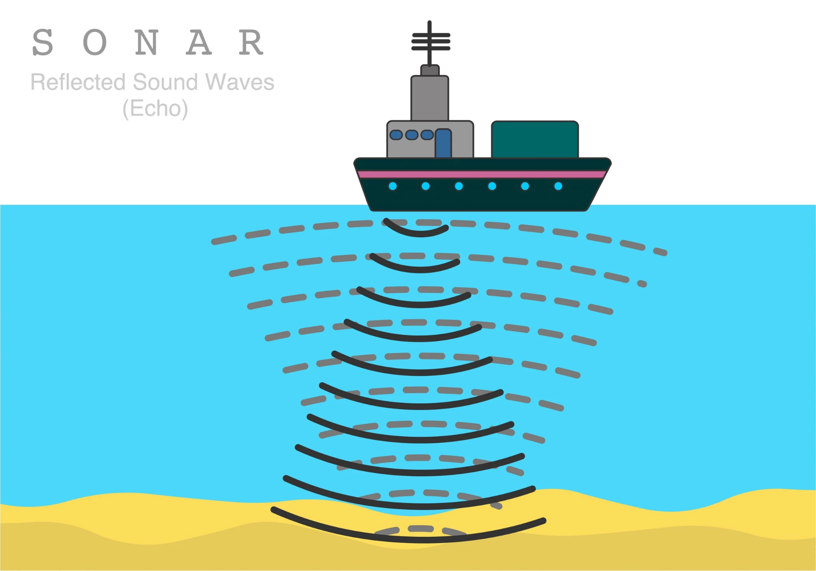
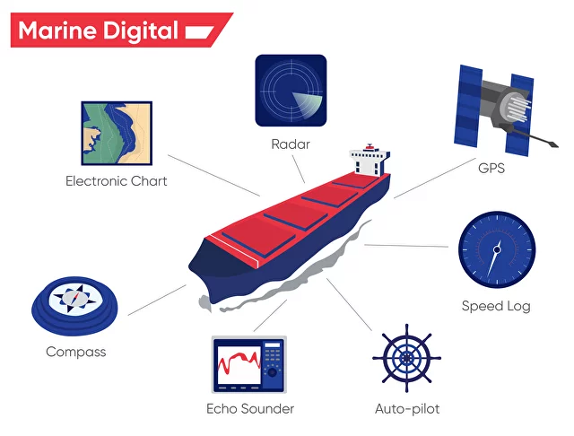

Ground vehicles - ground vehicles combine many of the tools mentioned above. For example, unmanned ground vehicles (UGVs) like autonomous mobile robots use many sources of data to navigate its environment like INS, GPS and WPS. In addition, these robots include different types of sensors to perceive its surroundings in order to do tasks. Some examples of sensors these machines can use are Light Detection And Ranging (LiDARS), proximity, touch, visual and infrared sensors.
Using the example from the Robotics and GPS section. The task for the robot was to locate and pick up an object. If the robot was in close proximity to the object, the robot could have done the task with less resources by using its combination of sensors. By using computer vision techniques, the robot could have used its visual sensors to detect the object. Next, the robot could use visual odometry and use any type of locomotion to reach the object's location. Lastly, the robot could have used its manipulators to grasp the object. If the robot was at a further distance from the object, and if this object had a GPS transmitter, then using the GPS would have been feasible.

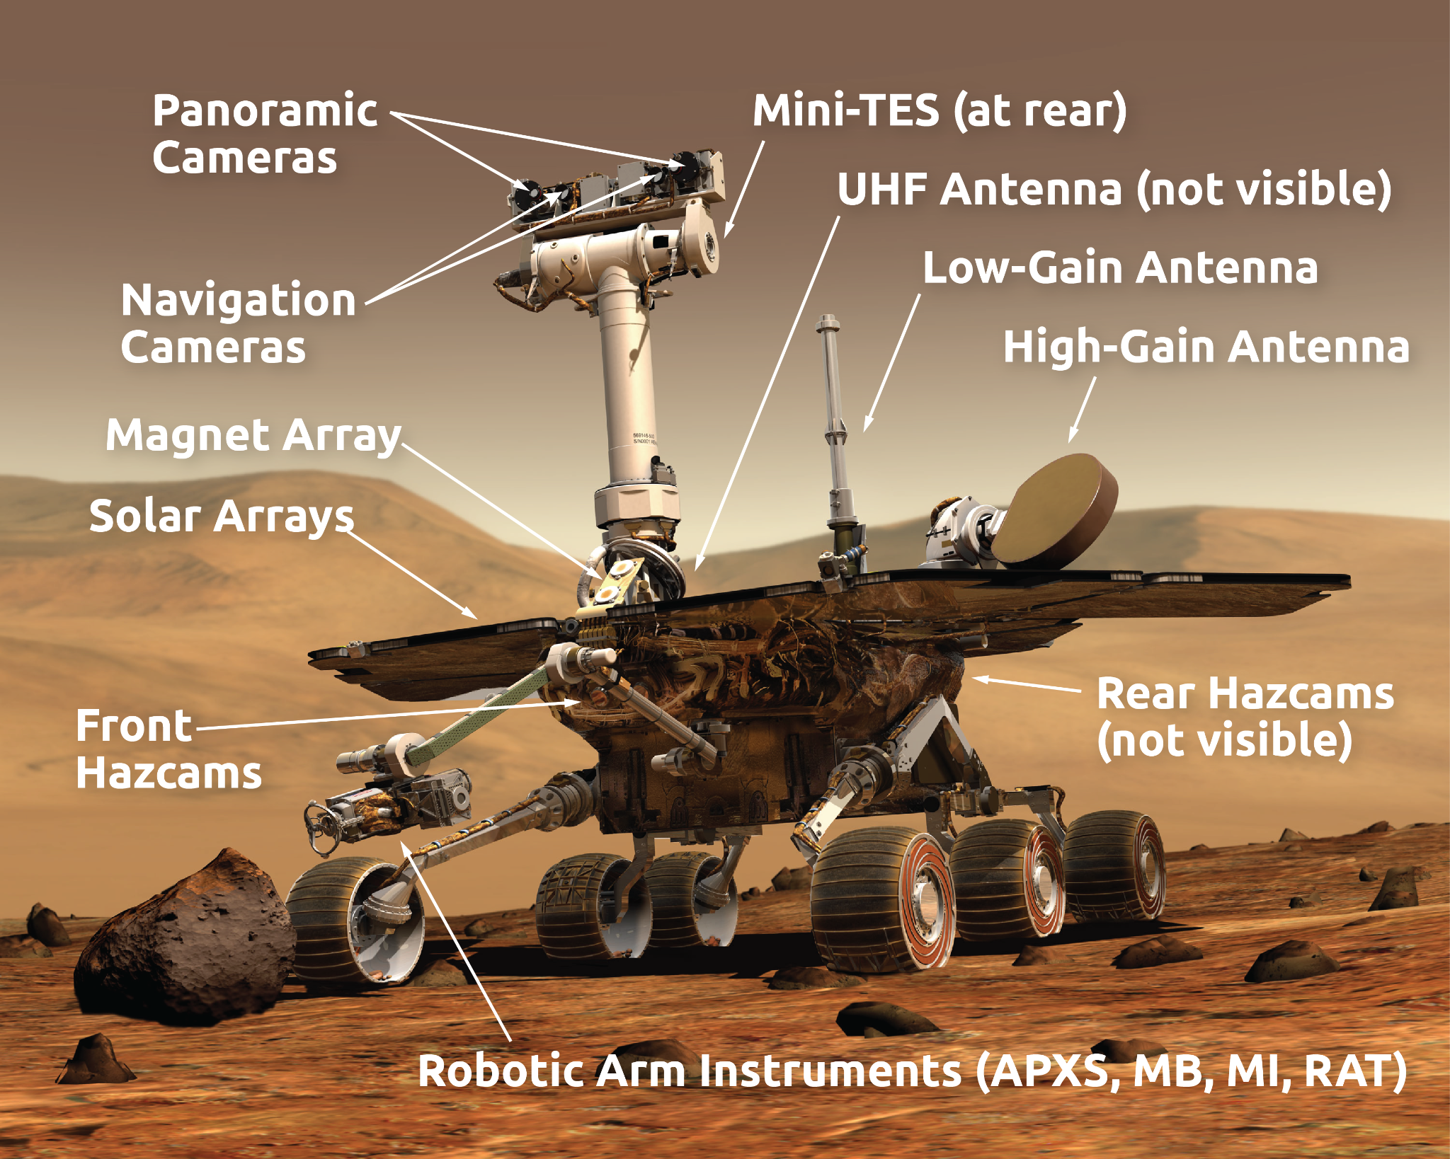

References
- Choi, H. S., Park, O. D., & Kim, H. S. (2005, June). Autonomous mobile robot using GPS. In 2005 International Conference on Control and Automation (Vol. 2, pp. 858-862). IEEE.Shentu, S., Gong, Z., Liu, X. J., Liu, Q., & Xie, F. (2022). Hybrid Navigation System Based Autonomous Positioning and Path Planning for Mobile Robots. Chinese Journal of Mechanical Engineering, 35(1), 1-13.
- Aerospace Navigation Systems. (2016). United Kingdom: Wiley.
- Coatantiec, J., & Guillard, P. (2006). U.S. Patent No. 6,982,669. Washington, DC: U.S. Patent and Trademark Office.
- Rizos, C., Grejner-Brzezinska, D. A., Toth, C. K., Dempster, A. G., Li, Y., Politi, N., ... & Sun, H. (2008, September). A hybrid system for navigation in GPS-challenged environments: Case study. In Proceedings of the 21st International Technical Meeting of the Satellite Division of The Institute of Navigation (ION GNSS 2008) (pp. 1418-1428).
- Alavi, A., Feng, M., Jiao, P., & Sharif-Khodaei, Z. (Eds.). (2022). The Rise of Smart Cities: Advanced Structural Sensing and Monitoring Systems. Butterworth-Heinemann.
- Barshan, B., & Durrant-Whyte, H. F. (1995). Inertial navigation systems for mobile robots. IEEE transactions on robotics and automation, 11(3), 328-342.
- Woodman, O. J. (2007). An introduction to inertial navigation (No. UCAM-CL-TR-696). University of Cambridge, Computer Laboratory.
- Liu, F., Liu, J., Yin, Y., Wang, W., Hu, D., Chen, P., & Niu, Q. (2020). Survey on WiFi‐based indoor positioning techniques. IET communications, 14(9), 1372-1383.
- Kelly, J., Saripalli, S., & Sukhatme, G. S. (2008). Combined visual and inertial navigation for an unmanned aerial vehicle. In Field and Service Robotics: Results of the 6th International Conference (pp. 255-264). Springer Berlin Heidelberg.
- Bao, J., Li, D., Qiao, X., & Rauschenbach, T. (2020). Integrated navigation for autonomous underwater vehicles in aquaculture: A review. Information processing in agriculture, 7(1), 139-151.
- González-García, J., Gómez-Espinosa, A., Cuan-Urquizo, E., García-Valdovinos, L. G., Salgado-Jiménez, T., & Escobedo Cabello, J. A. (2020). Autonomous underwater vehicles: Localization, navigation, and communication for collaborative missions. Applied sciences, 10(4), 1256.
- Ford, M. R., Ford, G., & McBride, M. J. The Evolution of the Global Positioning System.
- Atwell, C. (2021). What is sensor fusion? Fierce Electronics. https://www.fierceelectronics.com/sensors/what-sensor-fusion
- Clynch, J. (2001). A Short Overview of Differential GPS. The Oceanography Department at the Naval Postgraduate School. https://www.oc.nps.edu/oc2902w/gps/dgpsnote.html
- Navigation. (n.d.). Nationalgeographic.org. Retrieved June 30, 2023, from https://education.nationalgeographic.org/resource/navigation/
- US Department of Commerce, & National Oceanic. (2013). What is sonar? https://oceanservice.noaa.gov/facts/sonar.html
- Sturm, J. (2010). Gps: Global Positioning System. Rourke Publishing.

